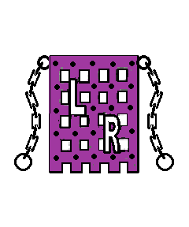
Race kindly sponsored by:
“Langport Runners”

BATTLE OF SEDGEMOOR

LANGPORT 10K 2016

Under ARC Rules Permit No. ARC16/131
& Fun Run
Sunday
28th August 2016
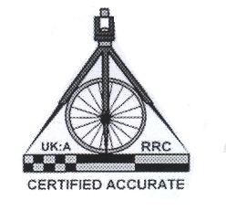START 11 a. m. at
The Langport Arms Hotel

COURSE RECORD PRIZES
Quality Momento to all Finishers

www.bos10k.co.uk
www.langportrunners.co.uk

14
Somerset
Race Series
2016

HELP THE EVENT: we are always looking for helpers, marshals and new members please contact Pete 01458 251486 if you are interested.

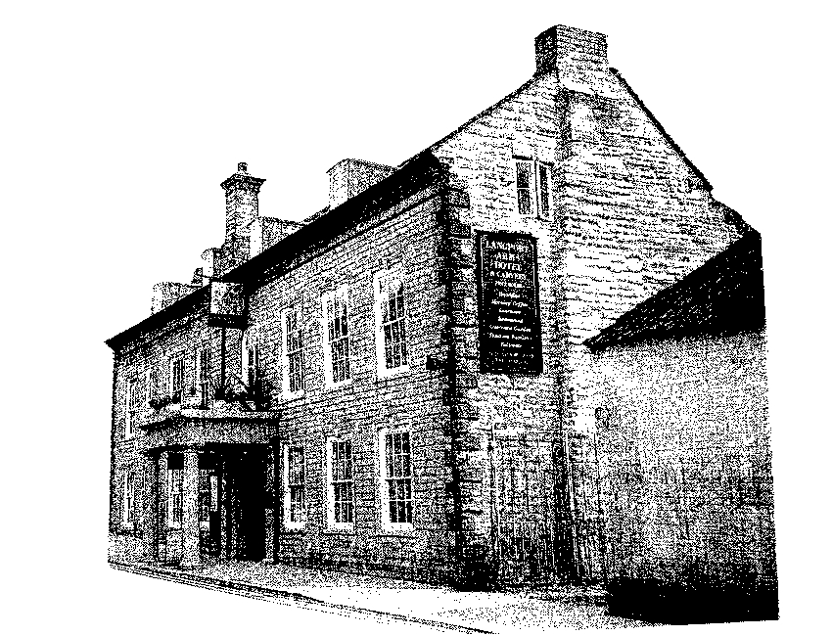

Langport Arms Hotel
And Carvery
Tel: 01458 250530
Fax: 01458 253885
e-mail: info@langportarmshotel.co.uk

We are always looking for Sponsors please contact us for details.

Website: www.bos10k.co.uk

FOR UP TO DATE PLACE ENTRY NUMBERS SEE WEBSITE LIMITED TO 600
A PHOTOCOPY OF THIS FORM IS ACCEPTABLE
BATTLE OF SEDGEMOOR 10K ROAD RACE

Event entered 10Km or Fun Run Leave Blank

Surname First Name

Date of Birth M or F

Club or Team Age on day of race

Is the Club affiliated Y/N ARC affiliated

Street

District

Town

County

Postcode

Best time for distance Estimated time this race

Home telephone number (STD essential) Work telephone number (STD essential)

Amount enclosed

I understand that the organisers and any person or body involved in the organisation of the event will not beheld liable for any injury, loss or illness occasioned from this event. I agree to abide by the Langport 10k Committee rules and understand their decision is final.

Signature - - - - - - - - - - - - - - - - - -
PLEASE ENCLOSE A LARGE STAMPED ADDRESSED ENVELOPE

Website: www.bos10k.co.uk / www.langportrunners.co.uk
Battle of Sedgemoor 10k Road Race
& Fun Run 2016
Once again the organisers of the Battle of Sedgemoor 10k Race look forward to welcoming everyone to our annual events.
The 10k Road Race will be a mainly flat but potentially fast race around the villages of Drayton and Muchelney and back to Langport, passing through some extremely scenic rural countryside.
The course is a measured 10,000 metres marked in Km. for pace judgement with one drinks station at about 6Km, and a sponge station at about 4Km. Course records:

Male 29.41 Nick Comerford (Cardiff) 2000
Female 34.26 Vicky Pincombe (Bideford) 2001

There will be Prizes and Trophies in all categories including teams.
Whatever category you enter under, we are sure there will be something for you. As always the course will be well marked and marshalled. The fun run is over a 2.5k multi-terrain course starting and finishing from the same points as the 10K.

The Start and Finish will be at the Langport Arms Hotel, as will the prize giving, as soon as possible after the event. Free public parking is available next to the Langport Arms and changing facilities will be in the Hotel. Please be aware if you park in the public car park at the race start there will be no exit until after the race completes. Alternative parking will be displayed on race day.
Bar snacks, teas and coffees will be available from 10.30a.m.
A stamped addressed envelope (9" x 6") for race details must be included for entrants in the 10k race or for the Fun Run, numbers to be collected on day with timing chip.

Universal entry forms, and photocopies accepted.
Entries on the day for the 10K race will be accepted - £2 extra.

Please submit your entry as soon as possible, together with a cheque/ Postal Order for £12 (£10 if affiliated) for each 10K Runner and £3.50 for each Fun Run Runner, made payable to: Langport Runners.

Postal entries close 14th August 2016.

Information, Entry Forms, S.A.E.'s and Entrance Fees to be sent to:

Pete Jones, West View, Somerton Road, Langport, Somerset TA10 9SY
Telephone: 01458 251486

Additional entry forms are available from the above address

Good Luck to all competitors taking part!

FOR UP TO DATE PLACE ENTRY NUMBERS SEE WEBSITE LIMITED TO 500

hrs mins mins
hrs mins

YES NO

